**ACTION ITEMS STATUS REPORT**

|  |  |
| --- | --- |
| **Report Date** | **Project Name** |
| **April 2022** | **Automated In-Plant Line Inspection Reporting System** |

|  |  |  |  |  |
| --- | --- | --- | --- | --- |
| **Task, Actions Items, Milestones, Deliverables Overview** | | | | |
| **Task/Action Items / Milestones** | **Actions/ Solutions Performed** | **Status** | **Date Completed** | **% Complete** |
| * Create a page for the function of POSMD | * Dashboard page * Account page * Meat Establishment Page * Daily Receiving of food Animals | On progress | 04/16 -30/2022 | 100 % |
| * Create a page for the function of POSMS | * Dashboard page (Region) * Account page (Region) * Meat Establishment Page (Region) * Daily Receiving of food Animals (Region) | On progress | 04/16- 30/2022 | 100 % |
| * Create a page for the function of Meat Inspector Officer | * Dashboard page * Meat Establishment Assigned * Ante-mortem, Post-mortem Inspection page |  | 04/16 - 30/2022 | 100 % |
| * Database structure | * Gathering some Data for the database structure | On progress | 04/16 - 30/2022 | 80% |
| * Process Analyzation | * Interviewing the end-user for the confirmation of the process | On progress | 04/16 - 30/2022 | 75% |
| * Meeting with the Project Manager, Process Owner and System Development Team | * Discussion about the progress of AIPLIRS and talk about the process created in IT terms including Database Structure, Process flow manual, Swimlane, Work Breakdown Structure | Done | 02/24/2022 | 100% |
| * Approved proposal process | * Swimlane, Database Structure, Output needed to be generated by the system | On progress | 04/16 - 30/2022 | 80% |
| * Creating a Page Prototype for the debugging of Database structure to meet the system requirement | * Page Created for the Meat Establishment Daily Receiving * Page created for the Meat Inspector | On progress | 04/16 - 30/2022 | 70% |
| * Creating a SIPOC for the mapping of Manual Process | * Mapping the process flow from Meat Establishment to Meat Inspector Officer to POSMS to POSMD | For approval | 04/16 - 30/2022 | 100% |
| * ALPHA test for the functional of the system | * Testing and debugging regarding for the movement of data | On progress | 04/16 - 30/2022 | 20% |
| * Meat Inspector, POSMS, POSMD page functions | * Added module for the role of meat Inspector for the additional of meat establishment assigned * Added module for the MMIR in every province, city | On progress | 04/16 - 30/2022 | 70% |
| * Revise process for the Meat Establishment | * Meat establishment will register online and the desired POSMS office per region will approved the application | On progress | 04/16 - 30/2022 | 80% |
| * Presentation | * Presentation of AIPLIRS and it’s every function | On progress | 04/16 - 30/2022 | 0% |

|  |  |
| --- | --- |
| **Version and Patch History** | |
| **Versions** | **Patch Updates Release** |
| January Changes and Updates | January 2022 |
|  |  |

|  |
| --- |
| Additional Comments |
| * Gathering Data for the confirmation of the process owner * Checking the last website of AIPLIRS developed and at the same time checking the process flow of the system * Creating a Swimlane, Database Structure to be discussed and for Approval. * Creating a prototype for the debugging of database structure, swimlane created |
| Recommendations |
|  |

|  |  |
| --- | --- |
| **Prepared by:**  **BAYOG, JUFREY NIÑO E.**  **Noted by:**  **DR. JANUARY M. NONES** | **Reviewed by:**  **MARIANNE JANE REPASO**  **Approved by:**  **DR. EASTER F. OBLENA** |

**Login page**

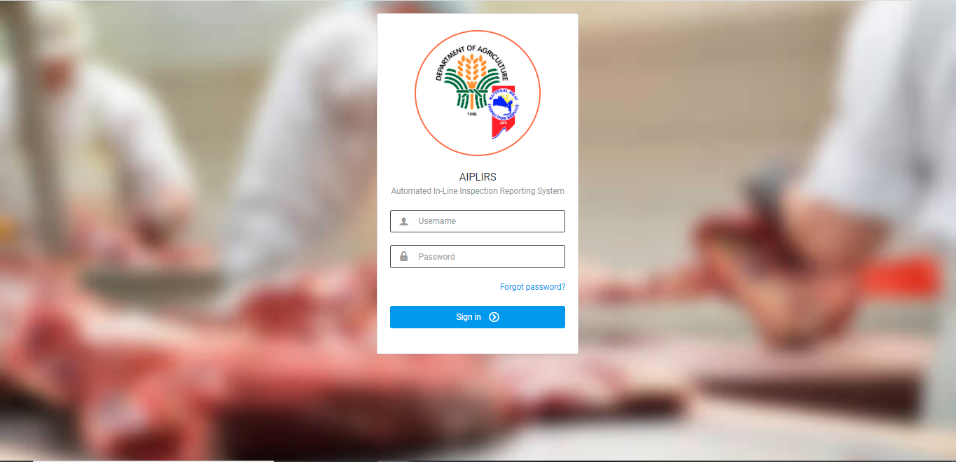

Daily Receiving Report

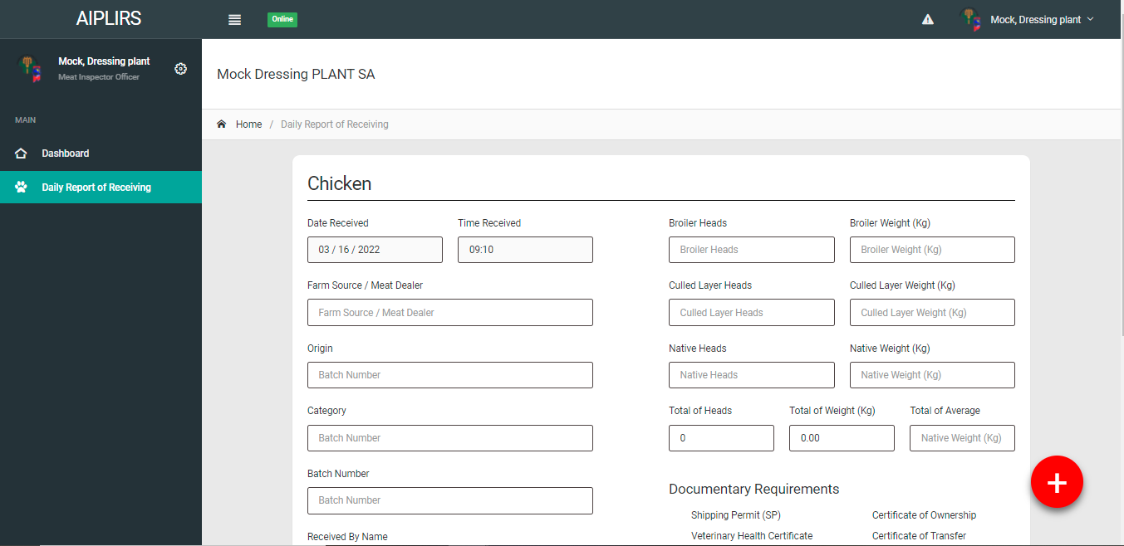

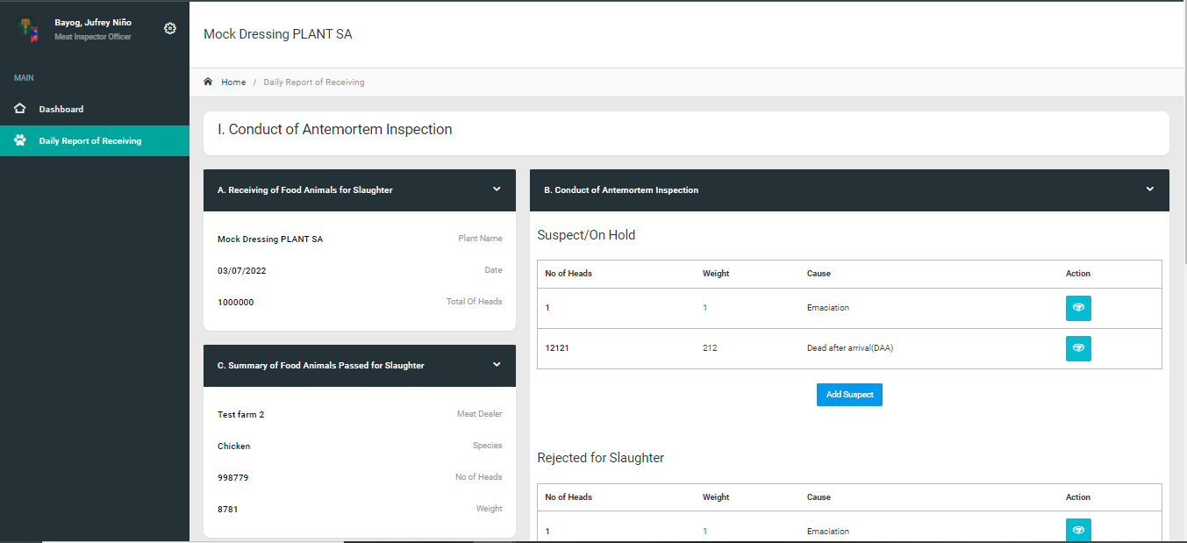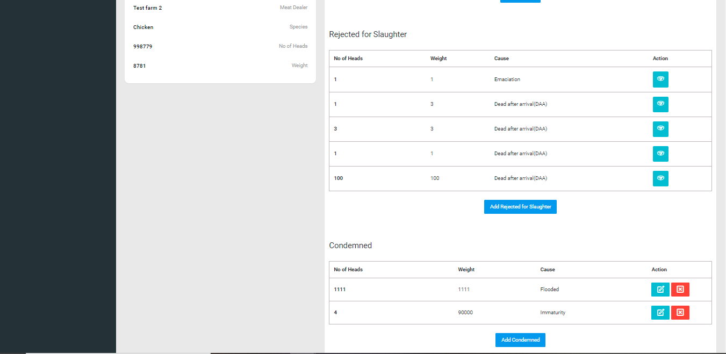

**AIPLIRS Swimlane**

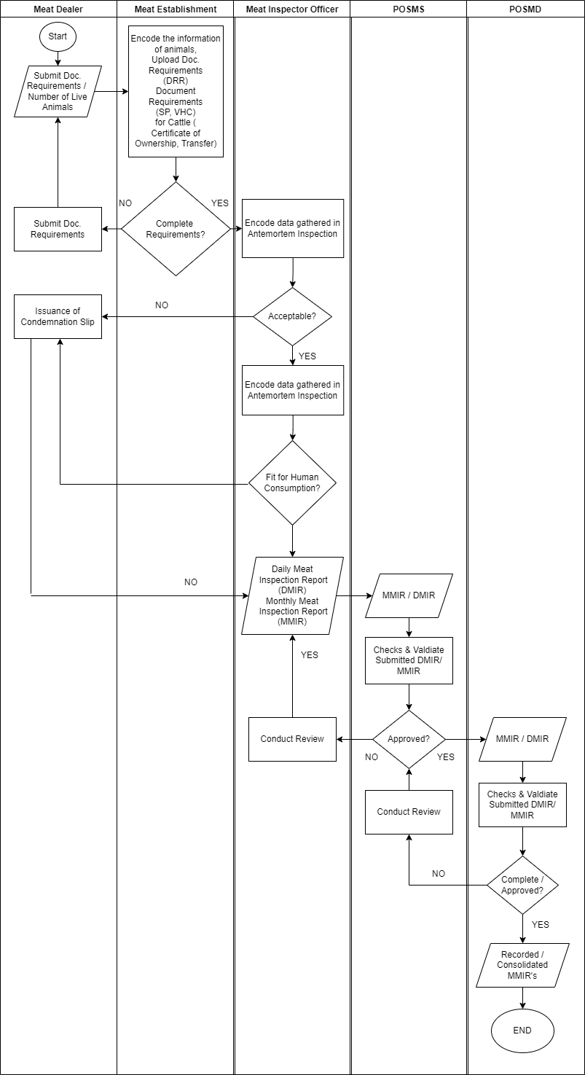

**AIPLIRS Database Structure**

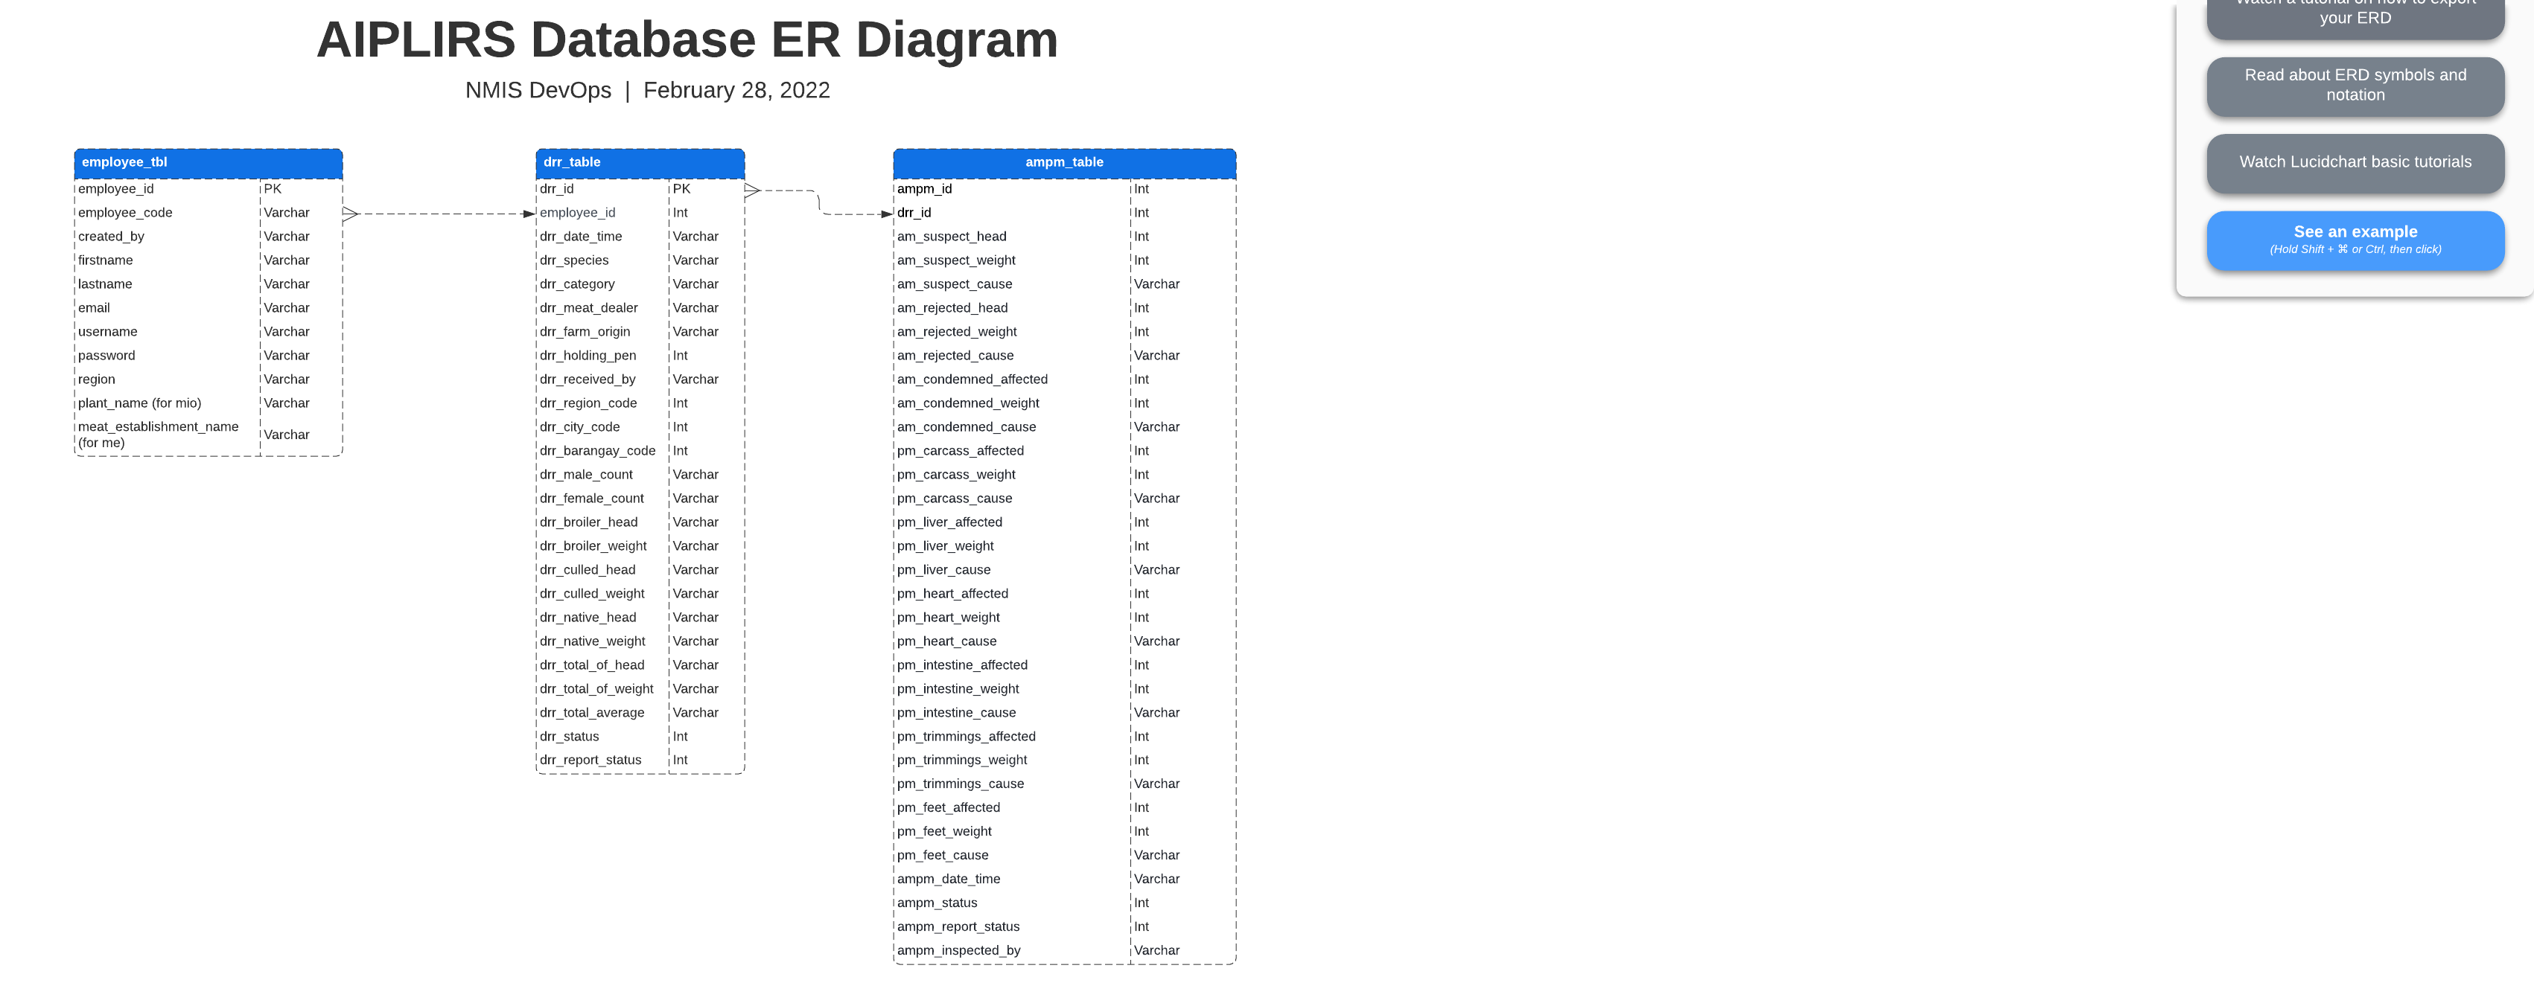

**AIPLIRS SIPOC Diagram**

|  |  |  |  |  |
| --- | --- | --- | --- | --- |
| **SUPPLIER** | **INPUT** | **PROCESS** | **OUTPUT** | **CUSTOMER** |
| Meat Establishment | Daily Receiving of Live Animals | Encoding of the number of heads, weight of the live animals received | No. of heads, weight of live animals | Meat Inspector Officer |
| Meat Inspector Officer | Antemortem Inspection data | Encoding for the Suspected / Rejected / Condemned Report | Antemortem Inspection Report / Food animals pass for Slaughter | Meat Inspector Officer |
| Meat Inspector Officer | Postmortem Inspection data | Encoding for the Carcass / Lungs / Liver / Heart / Intestines / Trimmings / Feet / Kidneys / Spleen Report | Postmortem Inspection Report | Meat Inspector Officer |
| Meat Inspector Officer | DMIR / MMIR | Submit Generate Report for DMIR / MMIR | DMIR / MMIR for approval | POSMS |
| POSMS | Validate DMIR / MMIR | Approve DMIR / MMIR Report, Inspected by Meat Inspector Officer | DMIR / MMIR Reports | POSMD |
| POSMD | Validate submitted report from the POSMS Regional Office | Approve DMIR / MMIR Report, Inspected by Meat Inspector Officer | Slaughter Reports | POSMD |